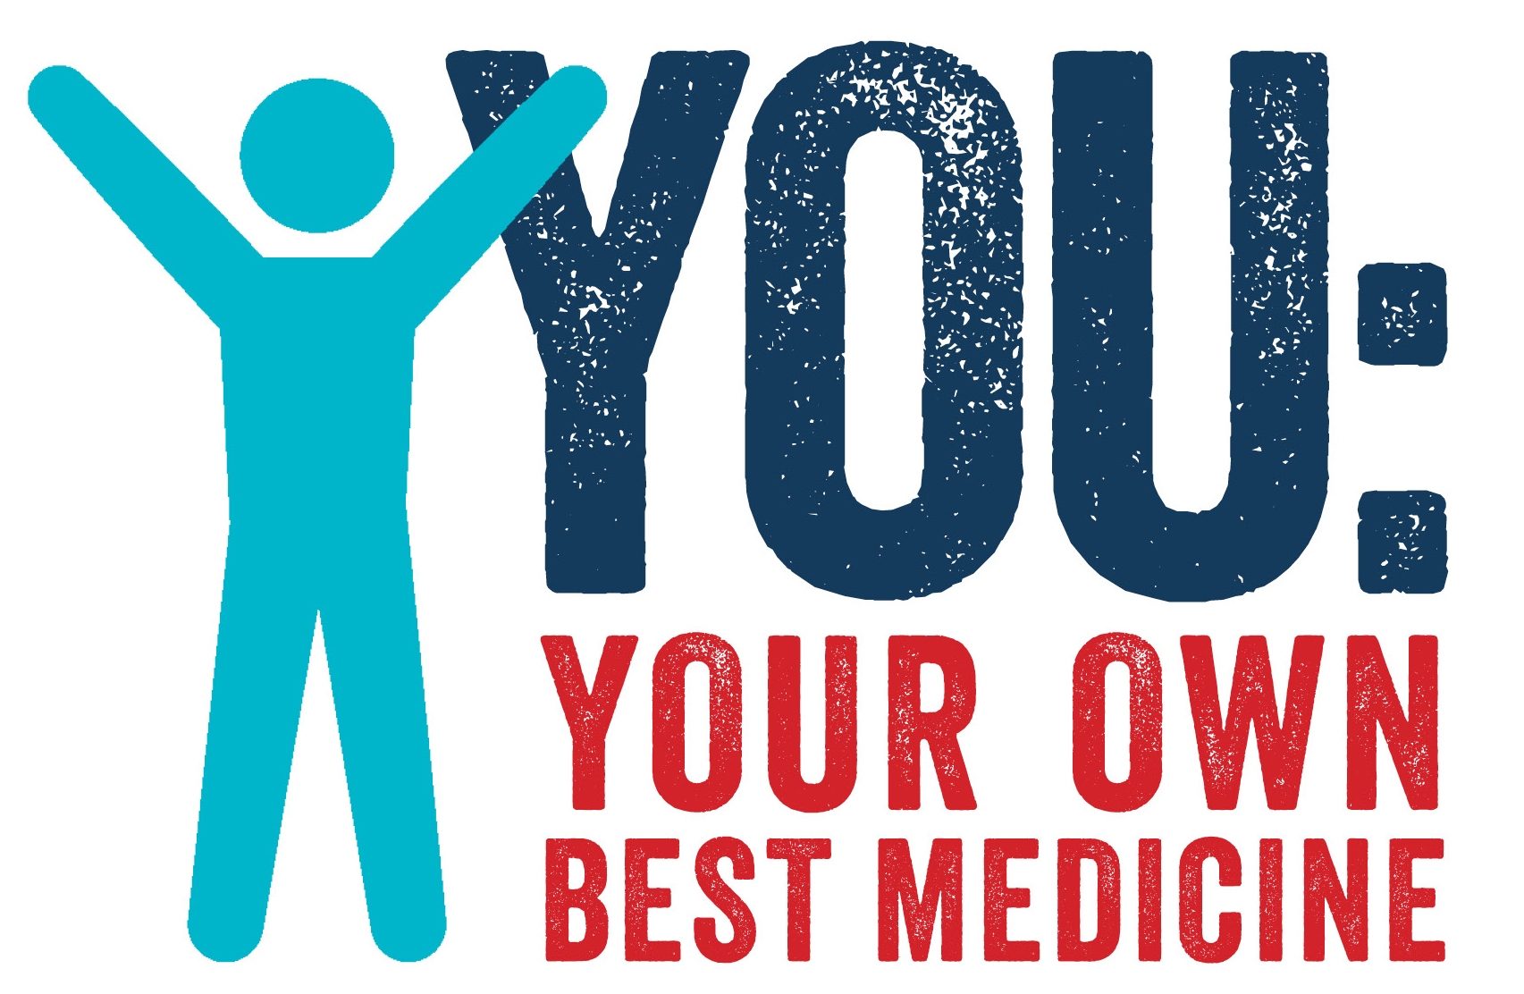

YOU: YOUR OWN BEST MEDICINE

BEFORE YOUR APPOINTMENT:

- BRING MEDICATION LIST. Bring a complete, accurate list to share.

- BRING TEST RESULTS. Bring all recent test results to share.

DURING YOUR APPOINTMENT:

- WRITE A WARNING SIGNS LIST. Ask about warning signs. Write them down.

- WRITE NEXT STEPS LIST. Ask about recommended next steps. Write them down.

AFTER YOUR APPOINTMENT:

- ACT ON NEXT STEPS LIST. Schedule appointments and tests. Fill prescriptions.

- WATCH FOR WARNING SIGNS. Alert your doctor if you have warning signs (see your list).

For more information www.ownbestmedicine.mn
Source: Minnesota Alliance for Patient Safety(MAPS)

